GEF-6 Project Identification Form (PIF)
Project Type: Medium Size Project
Type of Trust Fund:GEFTF

For more information about GEF, visit TheGEF.org

- PART I: Project Information
Project Title: | Scaling up the SE4ALL Building Efficiency Accelerator (BEA)
Country(ies): | Global | GEF Project ID: |  |  |  | 9329
GEF Agency(ies): |  | GEF Agency Project ID: |  |  |  | 01390
Other Executing Partner(s): | WRI (World Resource Insitute) | Submission Date: |  |  |  | 16 October 2015
GEF Focal Area(s): | Mitigation | Project Duration (Months) |  |  |  | 18
Integrated Approach Pilot | IAP-Cities IAP-Commodities IAP-Food Security |  |  | Corporate Program: SGP
Name of parent program: | [if applicable] |  | Agency Fee ($) |  | 190,000

A. indicative Focal Area Strategy Framework and Other Program Strategies
Objectives/Programs (Focal Areas, Integrated Approach Pilot, Corporate Programs) | Trust Fund | (in $)
 | Trust Fund | GEF Project Financing | Co-financing
CCM-1 PRGM 2 |  | 2,000,000 | 9,595,000
Total Project Cost |  | 2,000,000 | 9,595,000

B. indicative Project description summary

Project Objective:

Reduce greenhouse gas emissions by supporting market transformations that will enable a doubling of the rate of energy efficiency improvements in buildings by 2030, through linking global market experience with local policy action and capacity building.
Project Components | Financing Type | Project Outcomes | Project Outputs | Trust Fund | (in $)
 |  |  |  |  | GEF Project Financing | Co-financing
1. Partnership expansion: Global and local partnerships of businesses, NGOs and local governments scaled up to transform local efficiency markets | TA | 1.1 Public-private engagement in the Building Efficiency Accelerator expands and provides proof-of-concept that these innovative platforms can produce market shifts toward more efficient buildings at a subnational and local level as policy leaders implement new policy, projects and tracking approaches in commitment to Sustainable Energy for All.  Baseline: at the 2014 Climate Summit 5 cities joined the BEA. A dozen private sector and NGO partners “signed up” to the accelerator a the World Economic Forum.  Target:  - 30 total cities and 30 NGO’s/business groups commit to join the BEA and to 1) implement an energy efficiency policy, 2) develop a building project and 3) track and report progress. Expand companies and NGOs signing up to include all global regions. | 1.1.1 Dialogue summaries capturing input to subnational governments to address 5 major market barriers and support policy action. Participants include: supply side partners (technology and service providers, and financial institutions), demand side building owners and managers, and policy makers.  1.1.2 Regional diversity and best practice development: the BEA reaches 50 cities, signs up 30 cities and 30 leading companies/ organizations (5 key companies and 5 leading organizations each region). Cities who join commit to: implement policy, project, and track action. All partners expected to quarterly participation from each partner in BEA activities.  1.1.3. Local action summarized in support of the INDCs and climate commitments made at COP 21 delivered to the Global Buildings and Construction Alliance  1.1.4. Documentation of project results/lessons-learned produced and disseminated in cooperation with the BEA partners and Buildings Alliance. | GEFTF | 210,000 | 1,100,000
2. Technical assistance and capacity building for efficiency actions in cities (“Light touch”) |  | 2.1 30 Cities commit to the Sustainable Energy for All Building Efficiency Accelerator and through their engagement define and pursue a local policy/program and project to advance building efficiency.  Baseline: Assessment of existing buildings policies and actions in a committed city.  Target: In 30% of the 30 committed cites (10 light touch cities), at least one new action or one new project related to building efficiency is drafted, planned, developed, or adopted during the 18 month project period.  Indicator: City project development plans, municipal ordinances, project and actions identified through BEA engagement. Increased requests for deep engagement. | 2.1.1. Prioritization and assessment report of city level building efficiency policy and programs based on review of existing market information for each city. Supplement existing material as needed using partner tools/assessments.  2.1.2. Training and planning support provided to subnational governments by BEA partners/stakeholders:  a) multistakeholder input on policy opportunity assessments and prioritizations  b) Measurement and tracking methods  c) procurement strategy “checklist” and gap analysis  d) provide global best practice in policy, strategy and case studies  2.1.3. Knowledge management, regular high-value content sharing and communications across the network, and peer-to-peer learning. These will include webinars every 2-3 months, featuring the work of BEA partners.  2.1.4. Announcement at COP-21 on light touch and partner scale up, second announcement in Spring 2016. |  | 310,000 | 2,300,000
3. Place-based market transformation partnerships for policy and project implementation (“Deep dives”) |  | 3.1 Five “deep dive” cities + Mexico City define and advance policy action in a rapid acceleration including 1) a 6 month intensive multistakeholder engagement process 2) direct staffing and coordination support by local partners to move to policy and project prep/implementation.  3.2. “Light touch” cities request to be considered for deep dive engagement as part of a phase 2 of the BEA project.  Baseline: Existing efficient buildings policies and actions in a deep dive city reviewed against BEA policy menu and characterization of implementation status.  Target: In 100% of deep dive cites, at least one new action or project related to building efficiency is drafted, planned, developed, or adopted.  Indicator: Project development plans, and policy adoption through multi-stakeholder process. | 3.1.1. Market specific research compiled in support of policy and project development.  3.1.2 Working groups in each city agree on their activities, select co-leaders and provide efficiency vision and action ideas. Groups are comprised of key stakeholders and market actors.  3.1.3.Recommendations from working groups are provided to officials and released publicly.  3.1.4. Policies and actions are drafted or adopted and projects are identified and implementation is planned or underway within 18 months.  3.2.1. Proposal for phase 2 developed prepared for funder review based on successful phase 1 policy and market impacts. |  | 1,200,000 | 5,500,000
4. Monitoring and Evaluation |  | 4.1 Improved energy management practices at city and building scales; documentation of and communication about measurement, tracking processes, and results.  Baseline: to be determined based on cities selected  Target: in each city, one or more new or improved performance monitoring system (at the city or building scale and which includes building efficiency indicators) is adopted and reported to BEA.  Indicator: number of buildings, size of floor area and energy management approach undertaken. Policy assessment. | 4.1.1. Guidance for cities:  a. monitoring and reporting city-scale energy performance.  b. tracking building-scale energy performance.  4.1.2 Impact projections for policies and projects quantified by participating cities  4.1.3. Project impact evaluation undertaken by independent review at month 15 of the BEA project as part of potential phase 2 preparation. |  | 100,000 | 510,000
Subtotal |  |  |  |  | 1,820,000 | 9,410,000
Project Management Cost (PMC) |  |  |  | GEFTF | 180,000 | 185,000
Total Project Cost |  |  |  |  | 2,000,000 | 9,595,000
For multi-trust fund projects, provide the total amount of PMC in Table B, and indicate the split of PMC among the different trust funds here: ( )

C. Indicative sources of Co-financing for the project by name and by type, if available
Sources of Co-financing | Name of Co-financier | Type of Co-financing | Amount ($)
CSO | Business Council For Sustainable Energy (BCSE) | In-kind | 120,000
CSO | Buildings Performance Institute Europe (BPIE) | In-kind | 300,000
CSO | Clean Energy Solutions Center/NREL | In-kind | 85,000
CSO | Copenhagen Center on Energy Efficiency (C2E2) | In-kind | 350,000
Private Sector | Danfoss | In-kind | 45,000
CSO | Green Buildings Performance Network (GBPN) | In-kind | 135,000
CSO | ICLEI -- Local Governments for Sustainability | In-Kind | 2,230,000
CSO | Investor Confidence Project | In-Kind | 425,000
Private Sector | Ingersoll Rand | In-Kind | 310,000
 | Johnson Controls |  | 500,000
 | World Resources Institute (WRI) |  | 1,245,000
 | TECNALIA |  | 2,850,000
GEF Agency | UNEP | In-Kind | 80,000
 | UN Foundation |  | 50,000
CSO | US Green Building Council (USGBC) | In-Kind | 200,000
CSO | World Business Council on Sustainable Development (WBCSD) | In-Kind | 450,000
 | World Green Building Council (WGBC) |  | 220,000
Total Co-financing |  |  | 9,595,000

D. Indicative Trust FUND RESOURCES Requested by Agency(ies), Country(ies) and the Programming of Funds ^{a)}
GEF Agency | Trust Fund | Country/  Regional/ Global | Focal Area | Programming  of Funds | (in $)
 |  |  |  |  | GEF Project Financing (a) | Agency Fee (b)^{b)} | Total  (c)=a+b
UNEP | GEFTF | Global | Climate Change |  | 2,000,000 | 190,000 | 2,190,000
Total GEF Resources |  |  |  |  | 2,000,000 | 190,000 | 2,190,000
- Refer to the Fee Policy for GEF Partner Agencies.

E. Project preparation grant (ppg)
Is Project Preparation Grant requested? Yes No If no, skip item E.

PPG Amount requested by agency(ies), Trust Fund, country(ies) and the Programming of funds
Project Preparation Grant amount requested: $ PPG Agency Fee:
GEF Agency | Trust Fund | Country/  Regional/Global | Focal Area | Programming  of Funds | (in $)
 |  |  |  |  | PPG (a) | Agency  Fee (b) | Total  c = a + b
 |  |  |  |  |  |  | 0
 |  |  |  |  |  |  | 0
 |  |  |  |  |  |  | 0
Total PPG Amount |  |  |  |  | 0 | 0 | 0

F. Project’s Target Contributions to Global Environmental Benefits
Provide the expected project targets as appropriate.
Corporate Results | Replenishment Targets | Project Targets
- Maintain globally significant biodiversity and the ecosystem goods and services that it provides to society | Improved management of landscapes and seascapes covering 300 million hectares | Hectares
- Sustainable land management in production systems (agriculture, rangelands, and forest landscapes) | 120 million hectares under sustainable land management | Hectares
- Promotion of collective management of transboundary water systems and implementation of the full range of policy, legal, and institutional reforms and investments contributing to sustainable use and maintenance of ecosystem services | Water-food-ecosystems security and conjunctive management of surface and groundwater in at least 10 freshwater basins; | Number of freshwater basins
 | 20% of globally over-exploited fisheries (by volume) moved to more sustainable levels | Percent of fisheries, by volume
4. Support to transformational shifts towards a low-emission and resilient development path | 750 million tons of CO_{2e} mitigated (include both direct and indirect) | 3,821,252 tons CO2e (direct)
- Increase in phase-out, disposal and reduction of releases of POPs, ODS, mercury and other chemicals of global concern | Disposal of 80,000 tons of POPs (PCB, obsolete pesticides) | metric tons
 | Reduction of 1000 tons of Mercury | metric tons
 | Phase-out of 303.44 tons of ODP (HCFC) | ODP tons
- Enhance capacity of countries to implement MEAs (multilateral environmental agreements) and mainstream into national and sub-national policy, planning financial and legal frameworks | Development and sectoral planning frameworks integrate measurable targets drawn from the MEAs in at least 10 countries | Number of Countries:
 | Functional environmental information systems are established to support decision-making in at least 10 countries | Number of Countries:

part ii: project JustiFication

1. Project Description. Briefly describe:

- the global environmental and/or adaptation problems, root causes and barriers that need to be addressed,

The building sector is a major contributor to global warming. Buildings account for about one-fourth of global energy demand and nearly one-third of greenhouse gas emissions. The sector holds potential for some of the greatest areas of progress towards a more sustainable future, but is insufficiently addressed today. By 2050 global building energy demand can be reduced by at least one-third if known energy efficiency best practices are implemented on a large scale. Improvements to buildings in the urban environment can provide multiple benefits and improve quality of life: buildings are where city dwellers spend most of their time. Benefits of energy efficiency include easily quantified indoor and outdoor air quality improvements, greenhouse gas reduction, lower energy demand and costs, and more complex benefits such as improved urban liveability, worker productivity, as well as local employment.

Consensus on the urgency and seriousness of climate change continues to grow. There has never been a greater level of recognition of the role of energy efficiency as an essential element of providing a solution for climate change that will simultaneously benefit the global economy and contribute toward human development goals. In 2011, the United Nations launched the Sustainable Energy for All (SE4All) initiative to mobilize action towards a goal of doubling the global rate of energy efficiency improvement by 2030 from 1.5% to a 3% annual rate of improvement by 2030. This goal is achievable but activities must be quickly scaled.

- the baseline scenario or any associated baseline projects,

Electricity growth continues at approximately 5.7% year in non-OECD countries, with half of electricity generation (on average) from coal. The pace of electricity demand is determined by a number of factors including 1) increasing access to those living in energy poverty, 2) dramatic urbanization trends resulting in tremendous growth in the built environment and 3) additional energy consuming devices and space heating and cooling. With these macro trends, policymakers must look to energy efficiency strategies in the building sector to contribute significantly to stabilizing energy demand to meet a global 2-degree pathway.

The IEA found in its model of least-cost approaches that the global buildings sector can contribute emissions declines of 42 percent between 2012 and 2050 (around 80 GtCO2). Emissions reductions can occur at the same time that population, GDP, built floor space, and energy use are expected to grow. Technically feasible and cost-effective building efficiency solutions are available around the world in support of climate and energy goals. However, these solutions require significant shifts from business-as-usual construction and operation of buildings. And today, with the global population increasing from 54% urban to over 70% urban by 2050, we risk locking in a high carbon, low efficiency built environment if cities are not rapidly upgrading building construction and renovation practices.

Policies are critical to set the floor in terms of energy performance requirements. Most countries have written and passed building energy codes. The implementation and enforcement of these codes, however, is often the responsibility of local governments which may have limited capacity to adopt these codes or issue and enforce permitting. Policy action by cities can raise the floor and help eliminate in-efficient technologies and practice, but scaleable change at the pace required must include market transformation and private action.

Rather than technology or cost, the primary barriers building owners face when evaluating whether to make investments in improving efficiency are institutional and behavioural in nature. Decision-makers consistently cite five major hurdles they experience to improving building efficiency (InstituteBE.com):
- Lack of awareness of the specific opportunities and benefits of improving buildings,
- lack of technical expertise to evaluate options,
- uncertainty about the performance of efficiency projects or technologies,
- internal capital constraints or hurdles, and
- insufficient funds or finance options.

In addition, budgeting and procurement practices such as “lowest cost” sourcing may make investments difficult to justify because efficient technology may cost more upfront although it pay for itself very quickly and has a lower total cost of ownership.

Building owners often view energy efficiency favourably, but not as an investment priority. Improving efficiency is rarely prioritized over other business investments, and often there is limited staff knowledge or capacity to implement efficiency measures. In addition, many buildings are not owner-occupied, which means that building upgrades are the responsibility of the owner, but the reduced energy use only benefits the tenant of the building through lower energy bills. This “split incentive” also impedes owners from purchasing efficient equipment if it is not mandated or the lowest cost option.

Market implementation and technology deployment, as well as code adoption and enforcement relies on local government capacity as well as public and private decision-making. Alignment is across sectors is critical to success, as is awareness, financial capital and budgeting flexibility. This project addresses these very real forces that slow efficiency penetration and addresses local capacity issues to help shape the urban efficiency of the next decades.

- the proposed alternative scenario, GEF focal area strategies, with a brief description of expected outcomes and components of the project,

To address the complex human and institutional nature of the barriers identified above, the Building Efficiency Accelerator seeks to scale up its work at the intersection of policy and private markets. Its objective is to close the gap between inefficient practice and best practice by linking private sector market implementation experience with local policy action and capacity building. It does so by supporting market transformation to allow rapid scale up of energy efficient new and existing buildings, and working with cities and sub-national jurisdictions in their pursuit of building efficiency improvements.

With GEF support, this global partnership can share best practice, leverage in-market experience and support cities aspiring to accelerate policy and project action. The primary mechanisms employed include technical assistance (including localized assessments of barriers and opportunities), development of place-based partnerships to develop joint actions of the supply and demand sides of the building efficiency market, and staffing and in-kind resources (to incentivize local leaders to prioritize implementation of efficiency strategies and enable the policy/project development process to be actively driven forward).

The BEA partnership is one of 6 Accelerators launched in 2015 at the Climate Summit, and it focuses on subnational action. The BEA is complementary to, and coordinates with:
- The Efficient Appliance and Equipment Global Partnership (Appliance Accelerator) - Through the Appliance Accelerator partnership, participating countries will receive technical support and information, as well as funding for actions to promote the transition to efficient appliances and equipment. The creation of standards and national appliance efficiency action and diffusion strategies complements the BEA.
- The District Energy in Cities Initiative (District Energy Accelerator) – reducing carbon emissions requires re-examination of energy supply options. District heating and cooling options can be very efficient, offer resiliency benefits, and can be designed in concert with building technologies and renovations to deliver sustainability benefits. This is a “sister project” to the BEA, where the BEA focuses on driving down energy demand, which can be more easily met using localized district energy capturing improved economics and technology upgrades in integrated projects.
- The Lighting Accelerator (en.lighten) – by supporting efficient and advanced lighting technologies, the work of en.lighten will raise awareness and acceptance of highly efficient lighting technology. While much of the effort is geared toward street and public lighting, creating lighting technology awareness and standards will support rapid acceleration of these technologies in procurement strategies and help scale the availability of efficient lighting in global markets, benefiting interior lighting technology availability and cost effectiveness.

The corporate and NGO partners in the BEA and often touch more than one accelerator. Many have deep experience in markets around the world, which means that the work catalysed through the Accelerators will be reinforcing and can be sustained for efficiency action and market transformation. Bringing this broad and focused set of buildings sector experiences to subnational and local makes the BEA and the District Energy Accelerator efforts unique. The “ecosystem” of the market for energy efficiency requires additional attention and alignment in order to speed the delivery of efficiency solutions. The Energy Efficiency Accelerators brings together architects of national policies, international organizations, and local commitments and stakeholders to address market and policy gaps and barriers.

Many of the BEA partners are also participating in the formation of a new global Buildings Alliance which will be announced in Paris at COP-21. This Alliance provides a building and construction sector voice and perspective to national policy makers to help them harness these sectors in support of ambitious climate action. The Alliance’s work will challenge national leaders to consider the buildings sector as they plan for implementation of actions consistent with their Individually Defined National Commitments (INDCs). The Building Efficiency Accelerator’s work will result in demonstrable market transformation projects and policies in local jurisdictions, and help connect the national goals with local action to support enhanced ambition. This work at the city and sub-national level to deliver demonstrable market transformation in cities will create a pipeline of projects and policies for investment, which will be reported to the Alliance as well as to SE4All.

There are many partners, like WRI, ICLEI, GBPN and the World Green Building Council, with existing national and city government relationships. The partnership also covers a broad set of technical competencies ranging from building design to equipment options and to retrofit experience. These partners each have a significant number of existing and related projects, which are summarized in Attachment A, which serve as the backbone of the technical knowledge that helps accelerate action. The BEA partnership leverages and adds additional value to these projects by providing a mechanism and process for coordinated, on-the-ground application of the expertise, capacity and relationships of each partner.

There is growing momentum by cities to commit to emissions reductions and contribute to a global solution to climate change. The Compact of Mayors and other subnational government associations and partnerships continue to pledge ambitious action. These cities want to ensure that their actions to reduce emissions also contribute to their economic and social development goals—such as competitiveness, infrastructure, housing, inclusion. Many are embracing building efficiency because it can provide these multiple benefits.

There are policy roadmaps and excellent technical work is available internationally. The project relies heavily on the work and engagement with a variety of efforts. These include:
- policy analysis and the technology roadmaps conducted by IEA and the World Bank’s ESMAP program,
- experiences from C40 and ICLEI creating cross-city learning networks,
- Private sector engagements such as WBCSD’s EEB 2.0 which brings businesses together in a “lab” engagement process.

The project creates a “funnel” through which cities engage with the partnership, described in Diagram 1 below. The project partnership first reaches out to cities to build awareness (50 cities: component 1), then cities make a commitment to implement one project and one policy, track progress, and share best practice (30 cities: component 2), and finally a select group of cities in emerging economies work locally through a facilitated process to gather multistakeholder input and begin market transformation through public-private engagement and project development (6 cities: component 3). All cities are provided tools and training to track and measure actions (component 4).

Diagram 1: Building Efficiency Accelerator Project Plan/Process 2016-2017
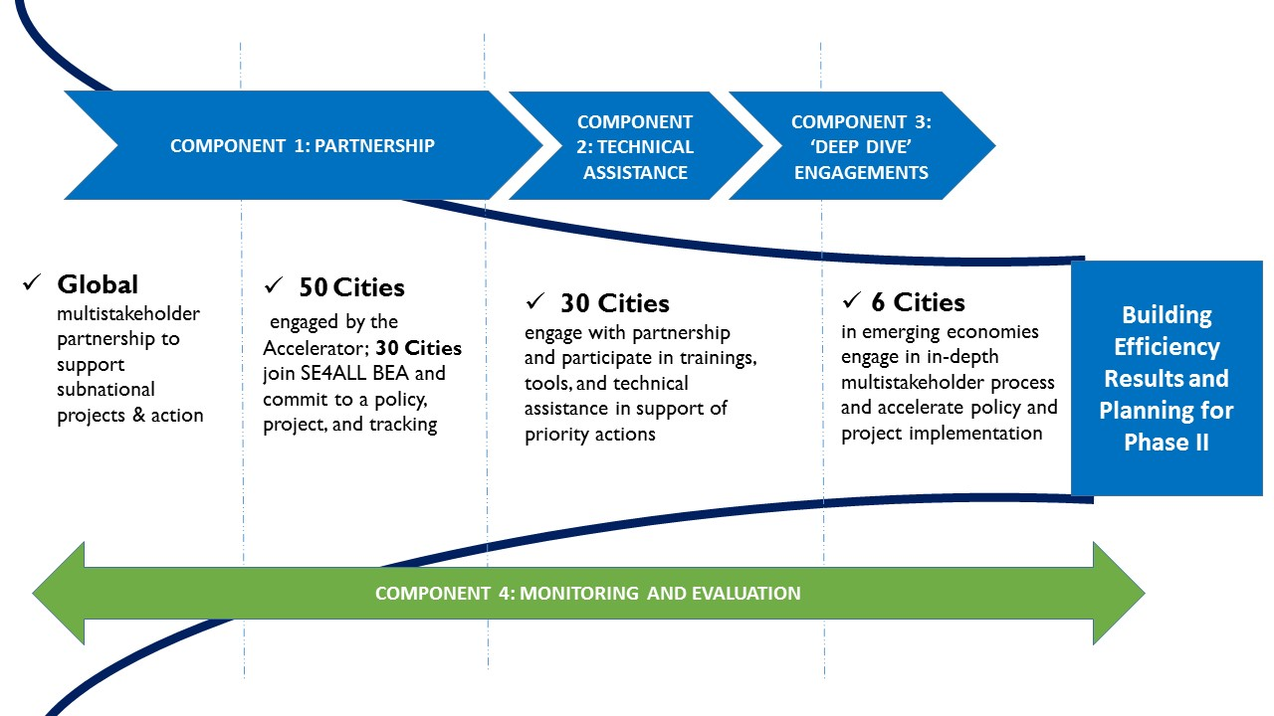
Component 1 Component 2 Component 3

Component 1: Transforming and scaling up local building energy efficiency markets using a global public-private partnership to deliver capacity and solutions

Expected Outcome: Public-private engagement in the Building Efficiency Accelerator expands and provides proof-of-concept that these innovative platforms can produce market shifts toward more efficient buildings at a subnational and local level as policy leaders implement new policy, projects and tracking approaches in commitment to Sustainable Energy for All.

This component will focus on catalyzing market transformation in key urban markets. It is based on the premise that through public-private engagement, local markets can demonstrate accelerated market development. With more local market development, cities can demonstrate support for broader national policies and align market efforts with local and national energy and climate goals. Local action can support increased ambition, and produces benefits for air quality, urban development, and climate change.

The project’s strategy is to partner with key stakeholders to support the scale up of building efficiency activities, policies and projects in support of the cities who sign up to the SE4All Initiative and the BEA. These activities bring new and relevant knowledge, best practices and tools to the attention of stakeholders and policymakers.

The scaling of the BEA across sectors and geographic regions will build a robust community of practice to support transformative change. In each geographic region, the project will deliver agreements from at least 5 leading private sector participants, 5 non-governmental organizations, and 5 trade and technical organizations in support of local and subnational governments. These strategic stakeholders will be drawn from the following stakeholder categories:
- Building technology and service providers (architects, contractors, product suppliers, etc.)
- Building owners/ managers
- Civil society/ academia
- Financial institutions

The project expects these representatives to participate in one or more regional and/or subnational BEA activity at least quarterly.

In 2016, the BEA aims to scale up its work with subnational and local governments to implement policies and projects in their jurisdictions. To achieve the scaling goal, the BEA will introduce SE4All to 50 cities over the next 2 years to encourage them to make commitments and undertake energy efficiency actions (See Diagram 1). From this 50, the BEA’s goal is that 30 cities will sign formal commitments with the SE4All BEA to pursue the goal of doubling the rate of energy efficiency improvements in their building sector by 1) implementing a building efficiency policy in their jurisdiction, 2) implementing a project and 3) tracking and reporting their progress.

To inform and recruit these 30 new commitments, at least 5 global or regional sessions introducing the BEA will be organized or held alongside events designed for subnational governments. Quarterly participation will be expected of each partner in the webinars and partner calls.

The momentum and lessons learned from this scaling effort will be used to influence broader adoption of a comprehensive approach to energy management. The partnership will support capacity building to track efficiency improvement in each city in line with the long-term goal of doubling the rate of energy efficiency improvement by 2030, and contributing to the sectoral action required to limit global warming under 2 degrees. In a second phase of the project (post 2017), an additional 20 cities would be targeted to make commitments.

Component Outputs

1.1.1. Dialogue summaries capture input to subnational governments to address 5 major market barriers and support policy action. Participants include: supply side partners (including technology and service providers, and financial institutions), demand side building owners and managers, and policy makers.

1.1.2. Regional diversity and best practice development: the BEA reaches 50 cities, signs up 30 cities and 30 leading companies/ organizations (5 key companies and 5 leading organizations each region). Cities who join commit to: implement policy, project, and track action. All partners expected to Quarterly participation from each partner in BEA activities.This includes: municipal governments, building technology and service providers, building owners/ managers/ occupants, civil society/academia, financial institutions

1.1.3. Local action and commitments in support of the INDCs and climate commitments made at COP 21 delivered to the Global Buildings and Construction Alliance.

1.1.4. Documentation of project results/lessons-learned produced and disseminated (blogs, case studies, summary reports) in cooperation with the BEA partners and Global Building and Construction Alliance.

Component 2: Technical assistance and capacity building for efficiency actions in cities (“Light touch” engagements)

Expected Outcomes: 30 Cities commit to the Sustainable Energy for All Building Efficiency Accelerator and through their engagement define and pursue a local policy/program and project to advance building efficiency.

The BEA global partnership will provide “Light Touch” support for dozens of cities each year, helping the 30 cities define their commitment and goals related to building efficiency. BEA will assist them in assessing and prioritizing actions through technical assistance, decision support tools, peer exchange, and other technical resources. Light touch support will be available to all subnational and local governments that commit to the Global Energy Efficiency Accelerator platform whether they are “inspiring” cities that have been pursuing building energy efficiency and are leaders already, or “aspiring” cities seeking to expand their sectoral focus and build capacity locally to implement and demonstrate action.

The project will seek to increase the number of efficient buildings policies and actions in each committed city, with the goal of having committed cites draft, plan, develop or adopt at least one new action and one new project related to building efficiency.

Three sets of tools will be made available to the cities, and training and support will be provided via regional workshops, webinars, case studies/best practice development and dissemination. These include:

Supporting city goal development and assessments – The project team will utilize existing action plans and experience as the foundation for engagement in the prioritization and action planning activity (including TRACE, WBCSD, IEA, EDGE and other bilateral and privately funded carbon, energy and building inventory analyses, project development plans, municipal ordinances, and completed project reports).

Assisting city partners with action planning, identifying and implementing programs – Leverage partner expertise and deliver to cities a menu of options includes: adopting codes and standards, retrofit project identification, green building planning and certification action, analysis of financing and funding models, and modifying administrative and procurement approaches in support of efficiency (Table 1).

Measuring and tracking progress – There are a number tools for tracking energy consumption in the buildings sector, GHG inventory development and low carbon planning, policy impact and change, new building and retrofit design and performance, and the operations and management of buildings. The partnership will support a suite of tools for cities to use, and will facilitate trainings.

As part of its commitment, by working with the BEA partnership, each city will select a policy to pursue from the menu of Policy Options (below).
Table 1. Policy Options |  | Offer Areas
Codes & Standards | Building codes to establish minimum requirements of energy performance. | √
Targets | Targets to align interests and spur action in the building sector. | √
Certifications | Certifications including green buildings that allow market differentiation of key environmental attributes. | √
Financial Mechanisms | Programs and incentives to provide funding to building efficiency improvements. | √
Government Leadership | Programs to support government efficiency, including public building retrofits and innovative procurement. | √
Benchmarking & Disclosure | Policies that generate data, baselines, and disclosure to support transparent building performance to the market. | √

The city engagement process starts with an interactive assessment and prioritization based on existing action plans, analysis or policy gaps. These ideas and materials are socialized and reviewed with local stakeholders.

Regional thematic, training and capacity building workshops will be planned and delivered to support city activities and share partner experiences. These workshops will be hosted with partner organizations as part of, or alongside, regional and global conferences and events. For example, the ICLEI World Congress hosted a BEA workshop in April 2015 to introduce SE4All to ICLEI cities.

These “light touch” regional events would be scheduled 3-4 times each year on average. To continue to regularly engage and support all BEA city partners the team will host webinars every 2-3 months to provide real life work and experience implementing policies in the “menu of policy actions” as well as topics such as financing approaches, energy data collection and analysis, local procurement strategies and others. Focused technical assistance will also be provided on a limited basis to light touch cities leveraging the partners’ expertise and bringing in local or global technical assistance organizations such as ESMAP, the Berliner Energy Agency, U.S. DOE’s Better Building Challenge, EBRD, sustainable cities initiatives and others to introduce and engage in technical discussions.

The project will result in several supplemental outputs for the purpose of knowledge management and dissemination. These outputs will include targeted local market research and one or more multi-stakeholder workshops in each deep dive city. There will also be trainings for the BEA partnership staff leads in the deep dive cities to learn from each other. Finally, research and communications materials documenting results and lessons-learned from the project, will be produced and disseminated. These will take the forms of blog posts, case studies and a summary report.

Component Outputs:

2.1.1. Prioritization and assessment report of city level building efficiency policy and programs based on review of existing market information for each city. Supplement existing material as needed using partner tools/assessments.

2.1.2. Training and planning support provided to subnational governments by BEA partners/stakeholders:
a) multistakeholder input on policy prioritization
b) Measurement and tracking methods
c) Procurement strategy “checklist” and gap analysis
d) Global best practice in policy, strategy, and finance

2.1.3. Knowledge management, regular high-value content sharing and communications across the network, and peer-to-peer learning. These will include webinars every 2-3 months, featuring the work of BEA partners, support learning among BEA cities and stakeholders. The partnership will enable peer-to-peer engagement, partner analysis, and implementation approaches of BEA partners. These webinars will engage a broader audience in the activities of the BEA including partners in the Buildings Alliance and other networks.

2.1.4 Announcement at COP-21 on light touch and partner scale up; second announcement in Spring 2016.

Component 3: Place-based market transformation partnerships for policy and project implementation (“Deep dives”)

Expected Outcomes: Five “deep dive” cities + Mexico City define and advance policy action in a rapid acceleration including 1) a 6 month intensive multistakeholder engagement process 2) direct staffing and coordination support by local partners to move to policy and project prep/implementation. “Light touch” cities request to be considered for deep dive engagement as part of a phase 2 of the BEA project.

The BEA partnership will engage with a core group of 6 cities (Mexico City plus 3 cities announced in December 2015, and 2 more cities announced spring 2016) to prepare for implementation of building efficiency policies and projects. These “Deep Dive” engagements in catalytic urban areas will serve as a model to shape and launch policies and project actions by “jump starting” market transformation efforts over a 1.5 year period. GEF funding will enable the BEA to expand dramatically from just working with Mexico City (that deep dive was initiated in March 2015), to launch activities in 5 additional cities during the period of the grant (2016-2017) in addition to continuing to work with Mexico City.

The activities in Component 3 seek to match market expertise, latent efficiency demand, and opportunities to access new transaction paths and financing. The partnership also provides momentum, visibility, and accountability for all involved. The locally-generated solutions that emerge are developed with an eye toward scaling them across the country and adapting them for other markets. Where there is a need to align local and national policies, the engagement will include national policymakers and ministries in the process.

A key element of the market transformation model unique to the partners: the BEA provides local staffing in deep dive cities, and a facilitated process to bring market participant experiences and expertise to support city policy and project action. In effect, this component leverages the most knowledgeable experts in the local market to help design effective strategies for the acceleration of building efficiency. This input is provided through an open, participatory process in support of the city’s identified goals.

The Deep Dive cities spend the first six months working in multisectoral working group sessions including at least one kick-off workshop per city, and then topical or activity focused working group meetings. The working groups are co-lead by stakeholder and city staff, and they must deliver recommendations to the city. Recommendations identify barriers and strategies to remove barriers for successful policy/project delivery.

The deep dive selection process will solicit nominations from a pool of candidate cities developed by SE4All, the BEA’s outreach and Accelerator partner relationships. The BEA Steering Committee will review information collected on each nominated city, assess each nominee against the established criteria, and obtain formal commitment from the local government before selecting the cities. Criteria include:
- Geographic and city size diversity;
- Pre-existing assessments of the opportunities/challenges in those markets so that the city is ready for “acceleration” rather than starting with light touch engagement;
- Opportunities to leverage in-kind or existing local government administrative staff or program resources;
- Support of local government engagement in the BEA from national government (including alignment with national priorities as identified in its INDC);
- Political commitment by the local government leadership, and a political term that will endure throughout the 1.5 year process;
- A “lead” BEA partner present in the city/region to facilitate the working group process and follow up work with the city;
- Strong local presence of the broader BEA partners and opportunity to link activities to include joint local delivery;
- Opportunities to expand and integrate benefits of the Accelerator platform including by partnering with the District Energy Accelerator to demonstrate how local energy solutions and building efficiency combined offer strong sustainability outcomes;
- Possibility for replication by other cities;
- Climate benefits.

The project will seek to ensure that each deep dive city increases the number of efficient buildings policies and actions, with the goal of having 100% of deep dive cites drafting, planning, developing or adopting at least one new action or one new project related to building efficiency. It is expected that each city will leverage its existing administrative staff and fiscal resources in support of the BEA partnership. As the cities engage in the process, these leveraged resources can be articulated and shared. It is important to capture the lessons, costs and benefits to communicate with other cities the resource requirements and cost/benefit analysis of BEA action. This will be particularly important in the planning for a Phase 2 project.

The project team will survey building project development plans, municipal ordinances, and completed projects, etc., created through multi-stakeholder processes that include participation of diverse and influential private sector actors.

Component Outputs:

3.1.1. Market-specific research compiled in support of policy and project development.

3.1.2 Working groups in each city agree on terms of reference for their activities, select co-leaders and provide efficiency vision and action ideas. Groups are comprised of key stakeholders and market actors.

3.1.3. Recommendations from working groups are provided to officials and released publicly.

3.1.4. Policies and actions are drafted or adopted and projects are identified and implementation is planned or underway within 18 months.

3.2. Proposal for Phase 2 developed for funder review based on successful demonstration of phase 1 policy and market impacts.

Component 4: Performance measurement and evaluation

Expected Outcomes: Increased capacity in Cities to establish baseline, implement and track buildings sector energy and emissions at both city and building scale and communicate results to policy makers and stakeholders .

BEA will work with cities to identify and utilize tools and methodologies through which city goals and the performance of buildings can be monitored. Building energy management capacity within the city and local stakeholder base will support efficiency tracking as business-as-usual and introduce reporting and metrics for use during the duration of the SE4All Initiative.

The project will introduce one or more new or improved performance monitoring system (at the city or building scale) adopted and reported to BEA. These tools include the Greenhouse Gas Protocol’s Policy and Action Standard, the Global Protocol for Communities (GPC), the Carbonne registry, the TRACE tool, the NAMAs accounting methodologies developed by UNEP.

The city and stakeholder team will quantify buildings, floor area and energy use changed as a result of the project actions using agreed upon methodologies and tools. To quantify and track the impact of policy actions, the team will support the use of tools such as the GHGP Policy and Action Standard, which is a protocol for establishing a baseline, calculating an ex ante and ex poste analysis framework that allows decisionmakers to calculate the GHG emissions impact of a policy option, and then track performance using the methodology over time. The Policy and Action Standard as well as the NAMA’s accounting methodologies have been specifically applied to building sector policy and project actions but additional programmatic use will help demonstrate the scale and track whether the calculated emissions change occurs over time.

The team will also ask a qualified consultant to review BEA project performance at month 15 of the project and suggest modifications to the program as well as reviewing and evaluating expected impact. This evaluation would also support a possible Phase 2 of the BEA for GEF and other funding.

Component Outputs:

4.1.1. Guidance for cities:
a. monitoring and reporting city-scale baseline.
b. tracking energy and emissions including building-scale energy performance

4.1.2 Impact projections for policies and projects quantified by participating cities

4.1.3. Project impact evaluation undertaken by independent review at month 15 of the BEA project as part of potential phase 2 preparation

Project Timeline (Gantt chart below):

Pre-Grant Preparation: October 2015 - April 2016:
- Engagement of global BEA partner organizations in additional city selection and development of comparative city opportunity assessment.
- Pre-launch: Selection of three first-round deep dive cities completed through nominations from global BEA partner organizations.
- December: Project launch announcement and communications at COP21 in Paris, France.

Scale Up Initiated: Spring 2016
- April: Project team launch meeting.
  - April-May: Local BEA partnership staff leader in place in first-round selected cities: 3 new cities, continuation of Mexico City activities.
  - May-August: Partnership formation – stakeholder identification and engagement, multi-stakeholder workshop, working groups formed.
- June: Global training/workshop for city staff leads and BEA partners.
- July-August: 2 cities selected and launched in second round deep dive cities.
- September: Local BEA partnership staff in place for second-round selected cities.
- October: Local action and strategy recommendations made by first round cities governments and other stakeholders by local working group in each first-round deep dive city. Related communications activities.
- November: 2nd global training/workshop for city staff leads and BEA partners.
- October-December 2016: 2nd group of cities finalize stakeholder identification and engagement, launch multi-stakeholder workshop, working groups formed.
- April 2017: 2nd round city stakeholder groups present recommendations to city governments. Related communications activities.

First Phase Wrap-Up: 2017
- November 2016-October 2017: first round of cities move to implementation of recommendations, development and implementation of policies and projects.
- May: Implementation planning and action begins in second round of cities. WRI hosts 3rd global training/workshop for city staff leads.
- June-September: Development of BEA Second Phase scale-up strategy, summary of lessons learned.
- October: Project summary report completed and disseminated globally and nationally through BEA and deep dive city partners to policymakers, investors, and thought leaders.

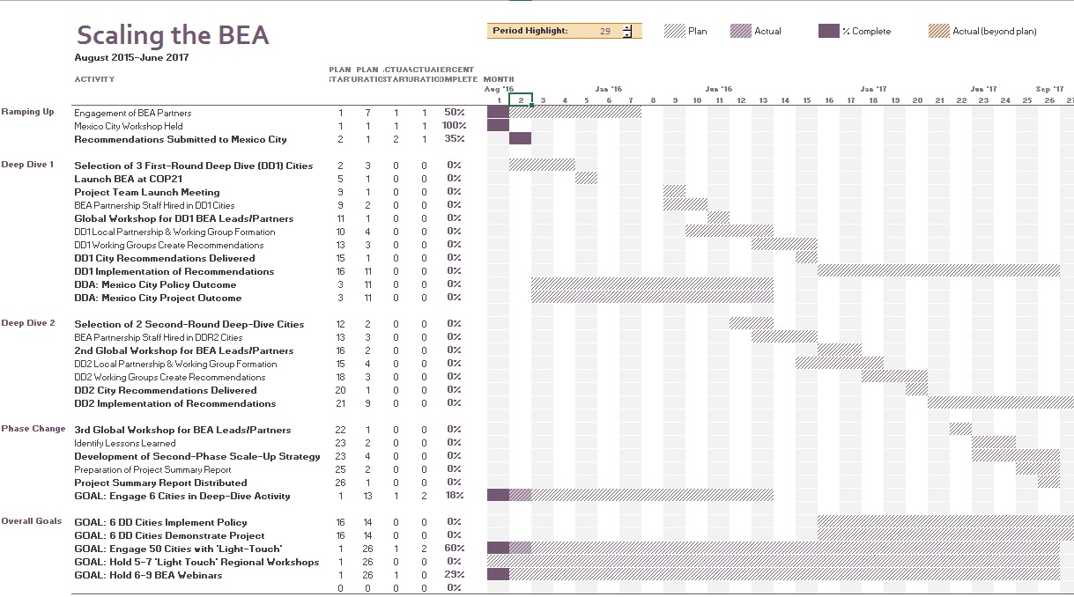

- incremental/additional cost reasoning and expected contributions from the baseline, the GEFTF, LDCF, SCCF, and co-financing;

Many cities and countries have energy efficiency standards in place for buildings. However few cities or countries employ an iterative process to review and revise their building codes together with emerging technology options for energy efficiency improvements.

This project aims to raise the bar on energy efficiency in buildings and provide cities with feed back on energy consumption in their building sector. This will begin to allow them to compare building energy consumption patterns between cities and allow city administrations to understand if there is room for improvement in energy consumption in their own buildings.

The activities of this project are considered to be barrier removal activities. On one hand construction companies and consumers bear the costs of building construction, while city administrations may have an asymmetry of information and be uncertain as to how stringently they can set energy efficiency standards without driving up the costs. The project will help cities to calibrate their building standards with current best practices.

- global environmental benefits (GEFTF) and/or adaptation benefits (LDCF/SCCF);

The Building Energy Accelerator (BEA) project’s goal is to support market transformation efforts around the world to demonstrate the power of public-private engagement to double the rate of energy efficiency improvements in buildings by 2030 and quantify the corresponding decrease in greenhouse gas emissions. Estimates of the greenhouse gas emissions mitigation benefits of the project have been prepared using Version 1.0 of “Calculating Greenhouse Gas Benefits of the Global Environment Facility Energy Efficiency Projects” and the related calculation tool. The project components are organized around the strategic global and local partnerships focused on action: making and supporting local Sustainable Energy for All commitments and action on building energy efficiency in cities. Public and private sector partners engage in a facilitated process focused on technical, process and capacity building efforts to forge a path for building-level transactions and policy implementation. The project’s direct aim is to catalyze and speed local implementation of locally-generated variations on energy saving strategies.

The project’s greenhouse gas reduction impact was calculated using conservative assumptions. The estimates include benefits from electric savings only, although in many markets served by the project, savings of thermal fuels may also result from the implemented efficiency strategies. Additionally, conservative assumptions were used on the energy and greenhouse gas emissions to avoid double counting savings from technologies deployed by other Global Energy Efficiency Accelerators—most notably the Lighting, Appliances and District Energy Accelerators. All impacts are calculated using the average emissions factors for Non-OECD countries. At this point of project preparation, the specific geographic markets in which the project will operate have not yet been selected.

The project results in a “Direct GHG emissions savings” of 3,821,252 tCO2 during the project and for the 15 years following project completion. The following paragraphs describe the methodology used in the calculations. In keeping with our conservative assumptions, estimates of “Indirect Bottom-up Emission Savings” are not included. More time is needed to review the considerations and agree on meaningful causality factors for indirect emissions, which will be done during project preparation.

Direct GHG Emission Savings

The benefits of all components of the project with quantifiable impacts are calculated using the GEF methodology for Demonstration and Diffusion projects with a participating city (or other subnational jurisdiction) as the unit of analysis. These choices were made because the specific building efficiency strategies implemented in each jurisdiction will vary considerably. The strategies will likely include, but not be limited to, building codes, building performance transparency policies, public buildings retrofit projects, and financing mechanisms. Separate calculations are made to estimate benefits for the two major quantifiable components of the project: 1) Technical assistance and capacity building for efficiency actions in cities (“Light touch” engagements) and 2) Place-based market transformation partnerships for policy and project implementation (“Deep dive” engagements). However, the methods for each are identical except for two variations: the level of electricity savings achieved in the cities taking action and the percentage of participating cities that ultimately take actions and achieving savings. The general assumptions are:

- 1,700 kWh/year/capita electricity consumption in each city (an approximate average for non-OECD cities as collected in the ESMAP TRACE database), 50% of which is used in residential, commercial and public buildings.
- An average city population of 2 million within municipal boundaries (a rough average of city size expected in the project counting only the jurisdictional population, not the larger urban area).
- As a result of the strategies implemented in a participating city taking actions, the project assumes that, compared to business as usual, light touch cities will achieve a 1% reduction in building electricity use in and deep dive cities will achieve a 2% reduction. It is assumed that, because of more direct support, deep dive cities will develop more actions and/or more effective actions and achieve a higher level of energy savings. These assumptions represent an average of savings that would result even with variations in the specific policies and actions implemented in each city. For light touch cities the estimate is based on an approximation of the energy savings achievable annually through implementation of a basic building energy code in new construction. For deep dive cities, it is based on a basic building energy code combined with one or more additional, more advanced energy saving actions. Business as usual assumes that 10% (the GEF default) of the GHG saving activities in the BEA jurisdictions would have happened without project interventions and are counted as part of the baseline.
- The project will work with 30 cities through the “light touch” component and 6 cities through the “deep dive” component. Project outcomes include targets that 30% (10) of light touch cities and 100% (6) of the deep dive cities will advance one or more efficiency action (policies, programs or projects). This is based on the assumption of higher success rates of getting implementation of actions in the cities where the project is more actively engaged in driving change. To align with these targets we assume that 10 light touch cities and 6 deep dive cities achieve electricity savings beyond business as usual.
- For actions that begin implementation at the end of our 18 month engagements, GHG savings will start accruing in 2017 and have a lifetime of 15 years (based on the default GEF assumption). However, based on the design of the GEF tool these savings are not dynamically calculated to grow over time as policies are implemented in additional buildings and savings accumulate over time; instead they are constant for each of the 15 years.

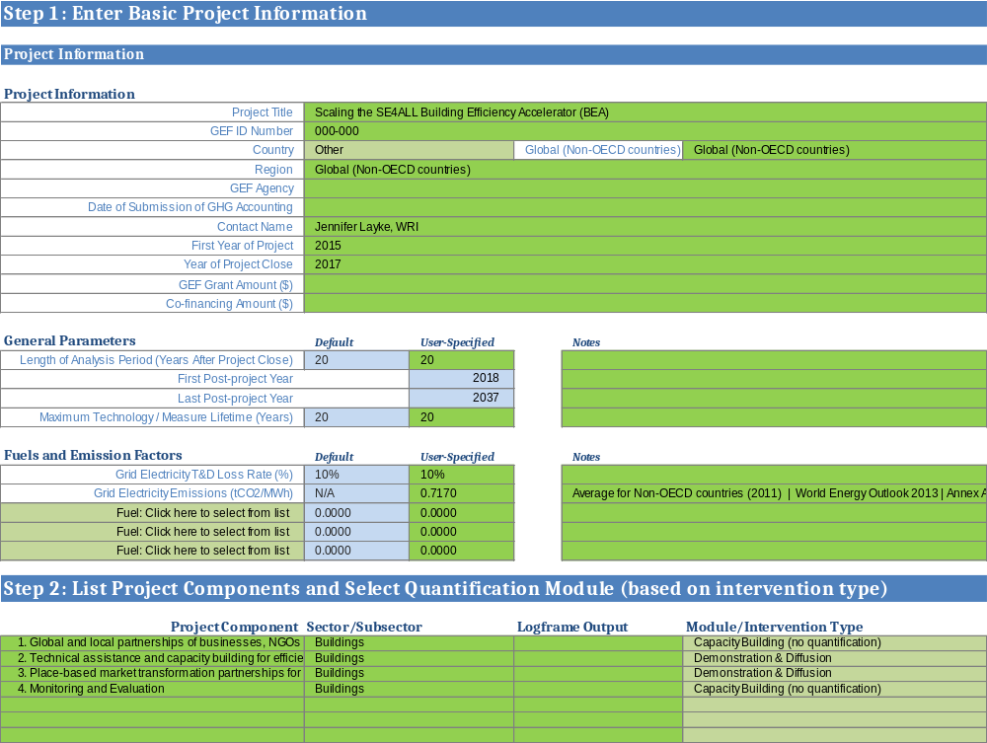

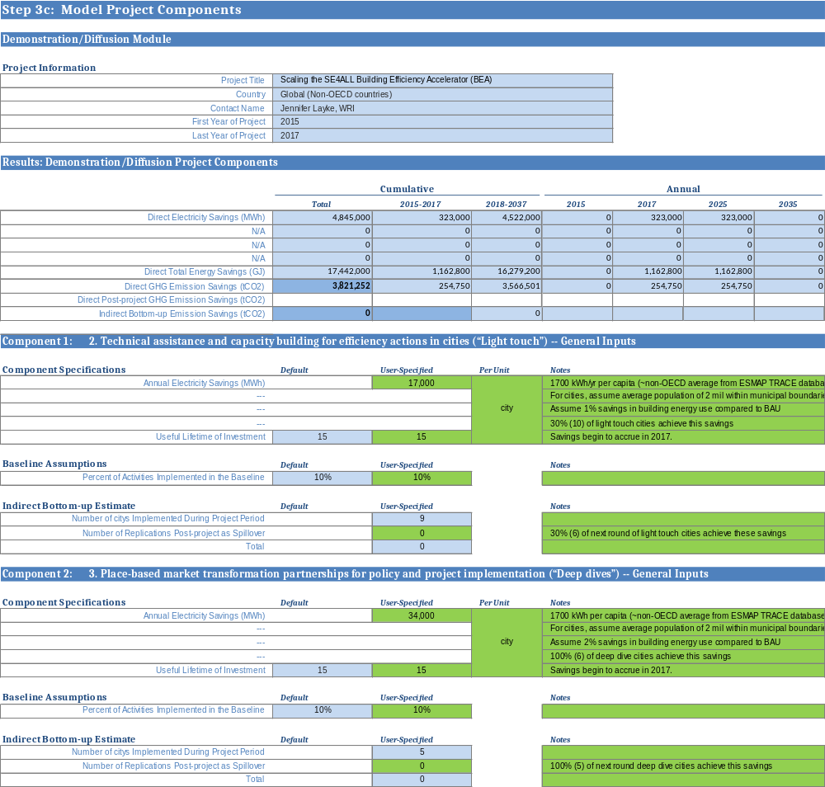

- Innovation, sustainability and potential for scaling up.

The BEA is testing an innovative approach to accelerating policy. The theory of change recognizes that two levels of alignment are critical if cities are to succeed: 1) removing barriers to help align markets and policy goals, and 2) leveraging and supporting ambitious national initiatives including bringing funding from national governments to city action alignment with national priorities, funding and support. Through the public-private engagement, the project will help market function more effectively and encourage private investment. The pilot efforts in the first phase will serve as a proof of concept that will allow for the project strategy to be refined and adjusted to systematically assist with efficiency adoption in cities.

The sustainability of this effort is designed in to the project. By bringing together local stakeholders we can consolidate and facilitate a common vision, common goals, capacity building on tools and strategies. In Mexico City, for example, there is a robust community which had a variety of activities and has now brought together their individual work into a facilitated structure. These working groups have met for 6 months to develop recommendations and are aligned in their support for city action. Each active global partner has defined their “offer” in terms of technical assistance and support for local and international actions. This enables the city partners and the community to know how and where resources are available so that technical issues, tools and policy implementation examples are available. The network of partners is a powerful mechanism which, if supported, can become self-reinforcing.

Beginning in mid/late 2017, if necessary resources are identified through GEF and other funders, a second phase of the project will focus on scale-up via coordinated partner implementation of the engagement methodology. This second phase will support new light touch and deep dive engagements in an expanded number of cities and enable continued engagement in first phase cities for implementation of more comprehensive efficiency strategies. The network community via ICLEI, WRI, the World Bank, the IADB and C40 have people, tools and relationships that are robust and can be vehicles for replicating the public-private partnership approach to support policy and project acceleration around commitments made by cities in the SEA4All Initiative.

- Stakeholders. Will project design include the participation of relevant stakeholders from civil society and indigenous people? (yes /no ) If yes, identify key stakeholders and briefly describe how they will be engaged in project design/preparation.

Civil society organizations are critical participants in the BEA. World Resources Institute (WRI), a global think tank working at the nexus of environment, economic opportunity and human well-being focused on delivering “ideas into action”, and WRI Ross Center for Sustainable Cities, WRI’s global program working in cities around the world on cross-cutting urban issues, act as the coordinating partner of the BEA. As the managing partner for the BEA, WRI is tasked with facilitating effective engagement among partners to the BEA and leveraging their research, market presence and engagement, and convening power to address problems in cities around the world through building efficiency solutions.

The BEA is a broad and deep partnership of policymakers, technology supply companies, technical support organizations, associations, and international institutions. The partners each bring their networks and knowledge and act together in a “learning by doing” model to accelerate action, building efficiency policy commitment and project implementation efforts. The current list of partners to the Building Efficiency Accelerator is included below.

Many are also helping shape the Buildings Alliance which will be announced at COP21 in Paris in December 2015. The Alliance will focus on supporting countries with engagement with the building and construction sector to achieve emissions reductions outlined in their Intended Nationally Determined Contributions (INDCs). The Building Efficiency Accelerator partners will demonstrate how subnational and local action can support these national goals. Because the BEA focuses on implementation activities, it is a complementary and integral part of the Alliance.

Attachment A summarizes some of the specific activities of BEA partners that are being provided as “offers” to the partnership. These offers range from the Global Building Performance Network’s benchmarking policy guidance to the Green Building Councils’ green certification criteria, to ICLEI’s municipal procurement guidance documents. Each partner brings its offer and geographical market knowledge to the benefit of the team and to the cities where the BEA partnership collectively works. ICLEI, WRI, GBPN, WBCSD, C40 (a prospective partner), and the Green Building Councils are all organizations that also have relationships or staff in multiple emerging economies and rapidly growing urban areas, enabling the development of customized engagements that match the needs of local stakeholders and competencies of partners. In addition to relying on partner networks, the BEA will work with Sustainable Energy for All teams and the UNEP-DTU Copenhagen Centre for Energy Efficiency (C2E2) in support of engagement for both the light touch and the deep dive engagements.

Table 2. BEA partners listed by category

Local Governments: | NGOs/Associations/Multilateral organizations: | Service providers/Companies:
Mexico City (Mexico) | World Resources Institute (coordinating partner) | Accenture
Milwaukee (USA) | Buildings Performance Institute Europe | Alstom
Muñoz (Philippines) | Business Council for Sustainable Energy | China Energy Conservation and Environmental Protection Group
Toyama (Japan) | Clean Energy Solutions Center/NREL | Danfoss
Warsaw (Poland) | Copenhagen Centre on Energy Efficiency (DTU) | Ingersoll Rand
 | Global Buildings Performance Network | Johnson Controls
 | Global Environment Facility | Philips
 | Global Green Growth Forum | Saint-Gobain
 | ICLEI - Local Governments for Sustainability | TECNALIA
 | UN Development Program
 | UN Environment Programme
 | UN Foundation
 | US Green Building Council
 | World Bank Group (ESMAP)
 | World Business Council for Sustainable Development
 | World Green Building Council

World Resources Institute will be supported by a Steering Committee which will be selected in the fall of 2015. Other elements of the governance structure, modeled to parallel the District Energy Accelerator’s approach, provides an inclusive structure for multi-stakeholder oversight and early stage input to BEA activities. The structure allows for fast near-term action and is being introduced to the partners for comment in the fall of 2015.

The proposed governance structure helps direct partner contributions within activities through the three taskforces:
- Technical Taskforce
- Capacity Building Taskforce
- Communication and Outreach Taskforce

Partners will review the Terms of Reference developed by the DEA for the taskforces and volunteer to serve. Partners will also be expected to support on-the-ground activities in cities.

3. Gender Considerations. Are gender considerations taken into account? (yes /no ). If yes, briefly describe how gender considerations will be mainstreamed into project preparation, taking into account the differences, needs, roles and priorities of men and women.

Inclusion of gender considerations and the perspective of women in the project design will help to mitigate risks to the project and generate efficiency actions that are more locally appropriate and effective. We will aim to include both gender-related education and gender inclusion as strategies in the project. For education, the intersection of energy efficiency and gender will be the core topic of at least one webinar in the BEA global webinar series. Additionally, we will consider hosting breakout sessions focused on gender at one or more deep dive workshop. For gender inclusion, balance in gender representation will be a core consideration in the development of workshops and working groups in deep dive cities, including ensuring significant representation of women as speakers, on panels, and among invitees/participants.

Other actions related to gender considerations that will be considered for integration in our work plan include:
- Analysis and discussion of the comparative preferences of men and women as expressed in policy prioritization exercises undertaken in workshops with Accelerator cities or candidate cities.
- Developing a review of building efficiency measures that are gender sensitive—including lighting and safety, thermostat setpoints, and equitable siting of building-related amenities—and identifying potential strategies to improve integration of the perspective of women in related decision-making.

4. Risks. Indicate risks, including climate change, potential social and environmental risks that might prevent the project objectives from being achieved, and, if possible, propose measures that address these risks to be further developed during the project design (table format acceptable).

Project risk | Measures to address
Competing partner priorities: Partner organizations have many projects and may deprioritize their engagement in the BEA. | - Ensure regular communication, align activities to ensure that delivery of BEA content complements and supports partner meetings around the world. With each partner, discuss and commit clear goals so that the BEA work is supportive to the partner’s mission, goals and activities.  - Actively identify opportunities for each partner’s participation to ensure they derive value from the partnership.
Partner capacity: Limited BEA network capacity and resources to support large numbers of light touch cities simultaneously. | - Subgrants to partner NGOs will provide supplemental resources to their co-financing commitments and also increase their level of commitment and responsiveness to meeting the needs of BEA cities.  - Targeted and limited engagement plans for each light touch city will be developed to help target organizational capacity to relevant markets.
Subnational government capacity: Local government staff may not have time, technical expertise, or political relationships. | - Deep dive engagements are specifically designed to address limited subnational government capacity. The BEA partnership will directly provide locally-based staff capacity to work with governments.
Competing government priorities: energy efficiency may be deprioritized in the face of other priorities viewed by leaders as more tangible or urgent. | - BEA staffing in deep dive cities will ensure clear and active focus on efficiency to actively and regularly engage government stakeholders on efficiency.  - The selection process reviews assessments of the opportunities/challenges in the markets selected. This helps to ensure that efficiency has previously identified as a local priority.  - In kind contributions will be required from each city, such as office or event space and local government champion designated by the Mayor.
Political risk: local government leaders may be hesitant to take steps viewed as politically risky. | - The BEA partnership provides a common vision and plan of action. This process is intended in part to mitigate political risk of new actions through coalition building.  - Selection criteria for deep dive market engagements prioritize cities that have national government support for local government engagement in the BEA.
Leadership change: change in leadership and priorities in local government or key local partner organization. | - Selection criteria for deep dive market engagements prioritizes those cities in which there is political commitment by the local government leadership and a political term that will endure throughout the 1.5 year process.
Data challenges: availability and format of energy-related data and market information | - The selection criteria for deep dive cities includes the presence of pre-existing assessments of the opportunities/challenges in the markets selected. This will help to ensure that at least basic market data is available and that the city is ready for “acceleration” rather than starting with light touch engagement.
Insufficient and incomparable systems for tracking results | - Systems and standard guidance for tracking and documenting learnings and progress will be established early in the project to ensure there is clarity and comparability between different project sites and timeframes.
Time lag of results: Major results of the project may not be seen before the end of the project period. | - The project team will identify interim goals for each engagement to track progress and leading indicators of project results.  - The project includes both strategy and resources for performance management, knowledge management and information dissemination.

5. Coordination. Outline the coordination with other relevant GEF-financed and other initiatives.

The BEA will coordinate with the other Sustainable Energy for All Energy Efficiency Accelerators to ensure that buildings, lighting, appliances, and district energy solutions are presented together and to leverage technical expertise across these communities. The BEA partnership regularly interacts with other SE4ALL Energy Efficiency Accelerators through global Accelerator Platform calls, meetings, and public events, and many BEA partner organizations are also partners to other Accelerators.

The BEA is focused on delivering city level efficiency, as is the District Energy Systems Accelerator, also known as the District Energy in Cities Initiative. The BEA and District Energy in Cities Initiative are already coordinating on outreach and assistance to cities through joint events and webinars. Selection of deep dive BEA cities will also be done in coordination with the District Energy Accelerator.

The Lighting Accelerator (“en.lighten”) may become an increasingly important partner over the course of the project if BEA cities express interest in improving both indoor/outdoor lighting at their facilities.

WRI hosts monthly coordination calls or meetings of the global BEA partner organizations to review the actions and activities underway by partner organizations working on behalf of the Building Efficiency Accelerator and share many partners with the other accelerators (see stakeholder engagement above.)

The GEF Sustainable Cities initiative presents an opportunity for collaboration based on its vital stake in innovative and efficient urban planning through coordination with local governments, and its emphasis on the transformative power of information and of quantifying energy flows through the urban infrastructure so that better decisions may be made. The Sustainable Cities initiative specifies an interest in “mainstreaming building energy efficiency codes in cities” under its integrated GEF-6 Climate Change Mitigation Focal Area – an effort the BEA already has under way in Mexico City and which it hopes to replicate in other committed cities. The BEA will coordinate via 1) invitation for representative of the Sustainable cities Integrated Approach Pilot to join the BEA Steering Committee, 2) quarterly coordination meetings, and 3) newsletter updates, lessons learned, case studies and knowledge products to be shared across the platforms to cross-fertilize solultions adoption in the buildings area. The BEA will also review and seek to make consistent methodologies for baseline establishment, tracking and progress indicators.

BEA also hopes for coordination with other GEF-funded projects relating to building energy efficiency, including recent projects on: improving energy efficiency in social housing in Trinidad and Tobago; efficiency air conditioning in Algeria; energy efficiency in Honduras’ hotel industry; improved energy efficiency in Vietnam’s high-rise buildings; and more.

BEA aims to collaborate with the Inter-American Development Bank (IDB)’s Emerging and Sustainable Cities Initiative, which is funded by the GEF. The Initiative aims to address complex challenges stemming from the confluence of rapid urbanization and climate change in the Americas, and there is great opportunity to leverage the IDB Cities network within the BEA to catalyze investment in building efficiency.

6. Consistency with National Priorities. Is the project consistent with the National strategies and plans or reports and assessments under relevant conventions? (yes /no ). If yes, which ones and how: NAPAs, NAPs, ASGM NAPs, MIAs, NBSAPs, NCs, TNAs, NCSAs, NIPs, PRSPs, NPFE, BURs, etc.

The Building Efficiency Accelerator partnership activities will be offered to cities within countries that have signed up to the Sustainable Energy for All Initiative as a way to ensure that there is national and local alignment.

This project establishes a global partnership with deep dives to support cities in countries that are non-annex I parties to the United Nations Framework Convention on Climate Change (UNFCCC). The alignment of their national government’s climate goals and the city action is critical. In looking for alignment, there are a number of indicators:
- Countries developing NAMA projects in energy efficiency policies and projects such as Mexico, India, Vietnam, Indonesia, Malaysia and the Philippines.
- INDC submissions from China, Jordan, Ethiopia and others that reference energy efficiency in buildings.
- Engagement with IPEEC, ESMAP and other technical assistance programs.

The En.lighten project team reviewed the submissions to UNFCCC in the technology assistance request process for prioritization of end use energy efficiency. They report that “Based on their national communications, most recent national plans, energy efficiency agencies, Technology Need Assessments (TNAs) and press releases, an overview of the priorities in energy efficiency has been developed for the 144 non-annex I parties to the UNFCCC eligible to receive GEF allocations. Out of the 144 countries, 52 have expressed interest in the implementation of measures for energy efficiency for end-use consumption, appliances, equipment and/or lighting or have started developing measures that are still at an early stage.”

Other countries and cities that have expressed a similar level of commitment will also be prioritized.

7. Knowledge Management. Outline the knowledge management approach for the project, including, if any, plans for the project to learn from other relevant projects and initiatives, to assess and document in a user-friendly form, and share these experiences and expertise with relevant stakeholders.

The project will result in a number of outputs for the purpose of knowledge management and dissemination. These outputs will include targeted local market research, as well as reports and summaries from the multi-stakeholder workshops conducted as part of the light touch and deep dive engagements. Partners will support these outputs and materials by providing access to their existing technical work and analysis as part of their in-kind contributions, as well as working to adapt and adopt their existing knowledge products to provide supplemental targeted materials for BEA through the grant’s research contracts. There will also be trainings for the BEA city partners and the project manager on key policy options, implementation and enforcement practices, and technical tools and methodologies such as measurement and verification approaches as needs are identified through the city and stakeholder engagement process.

Research and communications materials documenting results and lessons-learned from the project will be produced and disseminated. These will take the forms of blog posts, case studies and summary reports. One key dissemination strategy/approach is through the partner organizations, and a second is through the emerging Buildings Alliance. The BEA work has limited budget for broad communications, but clearly recognize the critical role our partners and their networks play in ensuring global outreach. Project materials including PowerPoints, reports, blogs etc. will be uploaded to a central project website and distributed via partners. Webinars will also be posted on YouTube.

For internal project coordination, the global BEA partnership hosts monthly coordination calls or meetings, as the deep dives expand, an additional global deep dive coordination calls will be instituted, and city-level partnership work plan tracking calls will be a standard management practice. The project will also establish guidance for BEA partners to use to track their activities, knowledge developed, and the impacts of their work.

part iii: approval/endorsement by gef operational focal point(s) and GEF agency(ies)

A. Record of Endorsement of GEF Operational Focal Point (s) on Behalf of the Government(s):
(Please attach the Operational Focal Point endorsement letter(s) with this template. For SGP, use this SGP OFP
endorsement letter).
Name | Position | Ministry | Date (MM/dd/yyyy)

B. GEF Agency(ies) Certification
This request has been prepared in accordance with GEF policies and procedures and meets the GEF criteria for project identification and preparation under GEF-6.

Agency Coordinator, Agency name | Signature | Date  (MM/dd/yyyy) | Project Contact Person | Telephone | Email
Brennan Vandyke, Director GEF Coordination Office, UNEP |  | November 10, 2015 | Ruth Zugman do Coutto, UNEP Energy Branch | +33 1 44 37 16 34 | Ruth.Coutto@unep.org

C. Additional GEF Project Agency Certification (Applicable Only to newly accredited GEF Project Agencies)
For newly accredited GEF Project Agencies, please download and fill up the required GEF Project Agency Certification of Ceiling Information Template to be attached as an annex to the PIF.

Project ID number will be assigned by GEFSEC and to be entered by Agency in subsequent document submissions.
When completing Table A, refer to the excerpts on GEF 6 Results Frameworks for GETF, LDCF and SCCF.
Financing type can be either investment or technical assistance.
For GEF Project Financing up to $2 million, PMC could be up to10% of the subtotal; above $2 million, PMC could be up to 5% of the subtotal. PMC should be charged proportionately to focal areas based on focal area project financing amount in Table D below.
PPG requested amount is determined by the size of the GEF Project Financing (PF) as follows: Up to $50k for PF up to$2m (for MSP); up to $100k for PF up to $3m; $150k for PF up to $6m; $200k for PF up to $10m; and $300k for PF above $10m. On an exceptional basis, PPG amount may differ upon detailed discussion and justification with the GEFSEC.
PPG fee percentage follows the percentage of the Agency fee over the GEF Project Financing amount requested.
Provide those indicator values in this table to the extent applicable to your proposed project. Progress in programming against these targets for the projects per the Corporate Results Framework in the GEF-6 Programming Directions, will be aggregated and reported during mid-term and at the conclusion of the replenishment period. There is no need to complete this table for climate adaptation projects financed solely through LDCF and/or SCCF.
For biodiversity projects, in addition to explaining the project’s consistency with the biodiversity focal area strategy, objectives and programs, please also describe which Aichi Target(s) the project will directly contribute to achieving.
For regional and/or global projects in which participating countries are identified, OFP endorsement letters from these countries are required even though there may not be a STAR allocation associated with the project.
GEF policies encompass all managed trust funds, namely: GEFTF, LDCF, and SCCF
D. Urge-Vorsatz et al., “Towards Sustainable Energy End-Use: Buildings.,” in Global Energy Assessment, vol. Chapter 10 (Laxenburg, Austria, Cambridge, United Kingdom and New York, NY, USA.: IIASA and Cambridge University Press, 2012).
D. Urge-Vorsatz et al., Best Practice Policies for Low Energy and Carbon Buildings. A Scenario Analysis (Budapest, Hungary: Research report prepared by the Center for Climate Change and Sustainable Policy (3CSEP) for the Global Best Practice Network for Buildings, May 2012), http://www.globalbuildings.org/global-projects/.
B Boza-Kiss, S Moles-Grueso, and K Petrichenko, Handbook of Sustainable Building Policies. Composing Building Blocks (United Nations Environment Programme (UNEP), 2013), http://sustainable-buildings-policy-assessment-tools.net/Content/PolicyPackages/ENG/SPoD-final-ALL.pdf.
IEA (2015) Energy Technology Perspectives 2015.
K. Managan et al., Driving Transformation to Energy Efficient Buildings: Policies and Actions, 2nd Edition (Milwaukee, USA: Institute for Building Efficiency/Johnson Controls, Inc., June 2012), http://www.institutebe.com/energy-policy/Driving-Transformation-Energy-Efficient-Buildings2.aspx.

